How to: Use the speakers notes and presentations

Each module consists of a speakers notes document and a presentation deck.

Each of the speakers notes documents breaks down the training session into sections. Each section has script – the main body of text outlining the main points to communicate during this section. Each section also includes a column on the left which contains the facilitation action needed during this section and suggestions for adaptations. There are estimated timings for each section and a total time estimate at the top of the document.
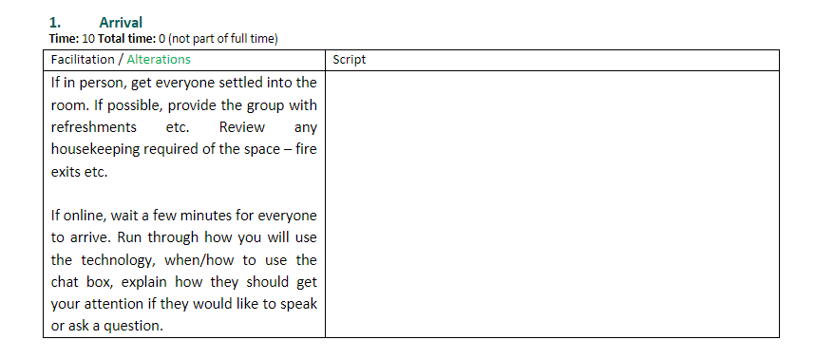
Green text indicates suggestions for alterations to tailor facilitation to a city needs / level of the group being taught. We recommend reviewing the materials ahead of time to identify where relevant city policies, examples can be referenced and added.

Blue text boxes indicate when an activity takes place.

We recommend reviewing the document ahead of time to ensure that you have all the materials you may need to complete the activities successfully. Most activities only require groups to have a shared space to write, this can be physically on paper or on an online whiteboard like miro.

